**To Implement A* Algorithm for an application.**

**1. *Introduction to A Algorithm*\***

The *A (A-star) algorithm*\* is one of the most popular and efficient search algorithms used in pathfinding and graph traversal. It is widely used to find the shortest path between two points in a grid, graph, or map. A* combines elements of Dijkstra's Algorithm and Greedy Best-First Search by using both actual and heuristic costs to prioritize paths that are more likely to lead to the optimal solution.

The A* algorithm is commonly applied in game development, robotics, and navigation systems where the goal is to find the most efficient path between points while avoiding obstacles.

**2. Key Concepts of A\***

A* algorithm works by systematically expanding nodes on a graph while calculating the cost of moving from one node to another. The algorithm uses two key values for each node:

* **g(n)**: The actual cost to reach the current node from the start node.
* **h(n)**: The heuristic cost, which is an estimate of the cost from the current node to the goal node (often using Euclidean or Manhattan distance).
* **f(n) = g(n) + h(n)**: The total cost for a node, combining the actual cost and the heuristic cost.

The A* algorithm finds the shortest path by minimizing the total cost, f(n), at each step.

**3. *Components of A Algorithm*\***

The A* algorithm consists of the following key components:

1. **Open List**: A priority queue that stores nodes to be evaluated, sorted by their f(n) value.
2. **Closed List**: A set of nodes that have already been evaluated.
3. **Heuristic Function (h(n))**: A function that estimates the cost of reaching the goal from the current node.
4. **Cost Function (g(n))**: The known cost from the start node to the current node.
5. **Path Reconstruction**: Once the goal is reached, the algorithm traces back through the nodes to reconstruct the optimal path.

**4. *Steps to Implement A Algorithm*\***

The A* algorithm follows these steps:

1. **Initialization**: Place the start node in the open list and set its g(n) to 0 and h(n) to the heuristic value.
2. **Node Expansion**: Repeat the following steps until the open list is empty or the goal is reached:
   * Choose the node from the open list with the smallest f(n) value (g(n) + h(n)).
   * Move this node to the closed list.
   * For each neighbor of the current node:
     + If the neighbor is already in the closed list, skip it.
     + If the neighbor is not in the open list, add it with the updated f(n) value.
     + If the neighbor is in the open list with a higher f(n), update its g(n) and parent.
3. **Termination**: When the goal node is reached, reconstruct the path by tracing back through the parent nodes.

**5. Heuristics in A\***

The heuristic function (**h(n)**) plays a crucial role in the performance of the A* algorithm. It provides an estimate of the cost to reach the goal from the current node.

Common heuristics used in A* include:

* **Manhattan Distance**: Often used for grids where movement is allowed in four directions (up, down, left, right).
  + h(n) = |x1 - x2| + |y1 - y2|
* **Euclidean Distance**: Used when movement is allowed in all directions.
  + h(n) = sqrt((x1 - x2)^2 + (y1 - y2)^2)
* **Diagonal Distance**: Used when diagonal movement is possible.
  + h(n) = max(|x1 - x2|, |y1 - y2|)

The heuristic should be **admissible**, meaning it should never overestimate the cost, to ensure the optimality of the A* algorithm.

**6. Example Application: Pathfinding in a Grid**

A classic application of the A* algorithm is finding the shortest path in a grid. In this scenario, the grid contains obstacles, and the goal is to move from a start point to an endpoint while avoiding obstacles.

**Example Grid:**

markdown

S = Start, G = Goal, X = Obstacle

-----------------

| S | | X | |

| | X | | G |

| X | | | |

-----------------

In this grid, the algorithm will use A* to find the shortest path from **S** to **G**, avoiding obstacles (**X**).

**7. *Pseudocode for A Algorithm*\***

sql

function A*(start, goal)

open_list = [start]

closed_list = []

g_score[start] = 0

f_score[start] = heuristic(start, goal)

while open_list is not empty:

current = node in open_list with the lowest f_score

if current == goal:

return reconstruct_path(came_from, current)

open_list.remove(current)

closed_list.append(current)

for each neighbor of current:

if neighbor in closed_list:

continue

tentative_g_score = g_score[current] + distance(current, neighbor)

if neighbor not in open_list:

open_list.append(neighbor)

else if tentative_g_score >= g_score[neighbor]:

continue

came_from[neighbor] = current

g_score[neighbor] = tentative_g_score

f_score[neighbor] = g_score[neighbor] + heuristic(neighbor, goal)

return failure

This pseudocode outlines the main steps of the A* algorithm: initialization, node expansion, and path reconstruction.

**Diagram**

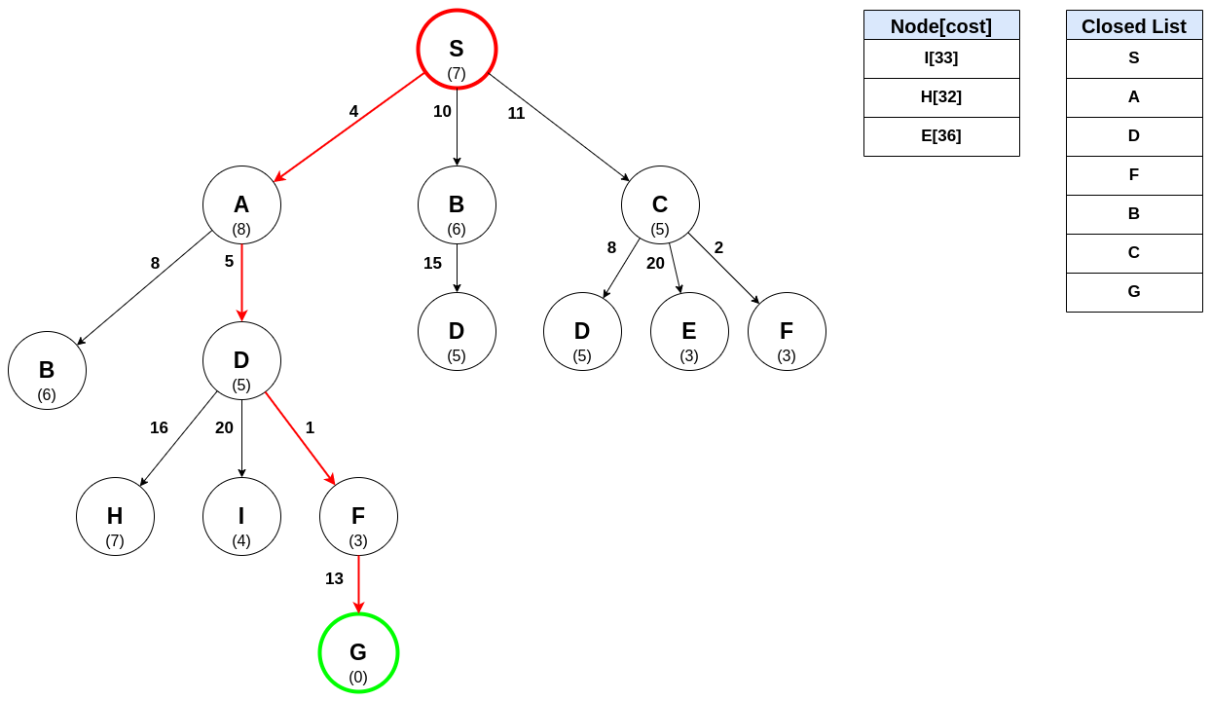**8. Advantages and Limitations of A\***

**Advantages:**

* **Optimality**: A* guarantees the shortest path as long as the heuristic is admissible.
* **Efficiency**: It is faster than Dijkstra's algorithm in many cases due to the use of heuristics.
* **Flexibility**: A* can be adapted for different applications by adjusting the heuristic function.

**Limitations:**

* **Memory Intensive**: A* stores all generated nodes in memory, which can lead to high memory usage for large graphs.
* **Performance**: The efficiency of A* heavily depends on the heuristic. Poor heuristics can lead to suboptimal performance.

**9. *Applications of A Algorithm*\***

The A* algorithm is widely used in various applications, including:

* **Pathfinding in Games**: A* is commonly used to control AI movement in video games, ensuring efficient navigation of characters through complex environments.
* **Robotics**: A* is used in robot path planning to navigate through environments while avoiding obstacles.
* **Navigation Systems**: GPS systems use A* to find the shortest or fastest route between two locations.
* **Network Routing**: A* can be applied to optimize routing in communication networks.

**10. Conclusion**

The A* algorithm is a powerful and flexible algorithm for solving shortest path problems in a variety of domains. Its combination of actual and heuristic costs allows it to efficiently find optimal paths while minimizing the computational effort. By adjusting the heuristic, A* can be tailored to a wide range of applications, from video game AI to robot navigation and beyond.